A An Truong Primary school. | THE FIRST TERM TEST
Name: Thái Ngọc Tường Vy | School year: 2025-2026- Grade: 3
Class: 3/5 | Time allowed: 30 Minutes.
Skills | Listening | Reading | Writing | Speaking | Total
Marks
Comments: |  |  |  | Supervisor signature

READING
TASK 1 : Read and complete. (1mark)

eight

hobby

Mary

name
Mr Long: Hi. What’ your(1)………………..?
Mary: My name’s (2)……………………………
Mr Long: How old are you?
Mary: I’m (3)………………….years old.
Mr Long: What’s your (4)…………………?
Mary: It’s swimming.

TASK 2: Read and circle .  (1mark)
- I have a book. |   A. |   B.
- Open your book, please! | 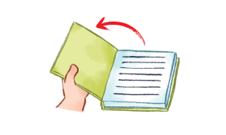  A. | 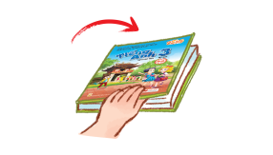  B
3. Let’s go to the classroom! |   A. |   B.
4.I play football at break time. |   A. |   B.

WRITING
Look and write. (2.marks)

  1. a-y-r-M M………… |   2. i-a-M M……………
  3. g i t h e e………………. |   c h o u t t…………………

